SHABBATON ON THE APOCRYPHA FOR AT ADATH SHALOM
CONGREGATION, OTTAWA, CANADA (14 JUNE 2020)
Draft of 12 June – Oral Version – Delivered by Zoom
Estimated length – about 1.5 hours
(20 minutes for D’var; 2 hours for Parts 2, 3 and 4)

Acknowledgements
Several people helped me with preparation of these documents. Most important was Dr Caroline Pestieau, my colleague at Canada’s International Development Research Centre, who had a strong Catholic education and helped me explore initial and later Catholic attitudes and activities related to The Apocrypha. Rabbi Elizabeth Bolton of Synagogue Or HaNeshamah in Ottawa worked with me on The Additions to the Book of Esther. Rabbi Emeritus Reuven Bulka of Congregation Machzikei Hadas in Ottawa and Rabbi Deborah Zuker of Kehillat Beth Israel, also in Ottawa, both took time to tell me of the role that The Apocrypha had played in their education and experience. I am also grateful to the ten or a dozen congregants of Adath Shalom in Ottawa who sent me comments or excerpts of materials concerning The Apocrypha, some of which now appear in this text.

THE APOCRYPHA
CONTENTS*
- The First Book of Edras
- The Second Book of Edras
- The Book of Tobit
- The Book of Judith
- The Additions to the Book of Esther
- The Wisdom of Solomon
- Ecclesiasticus or the Wisdom of Jeshua the Son of Sirach
- The Book of Baruch
- The Story of Susanna**
- The Song of the Three Children**
- The Story of Bel and the Dragon**
- The Prayer of Manasseh
- The First Book of Maccabees
- The Second Book of Maccabees

*Edgar J. Goodspeed (1938), The Apocrypha: An American Translation, New York: Vintage Books/Random House, page xi.
** In some versions these three chapters are grouped into one book entitled The Additions to Daniel

THE APOCRYPHA

- It is only an approximation to say that the book that we call The Apocrypha appeared between the Hebrew Bible and the Catholic Bible, which is to say in the last century BCE. Final adjustments to the Hebrew Bible were still being made at the time of the Mishnah in the 2nd century CE. There never was a formal canonization process for our Bible, but by the 4th century CE it was in the form that we know today. The 14 chapters that make up The Apocrypha, and that, as I will explain shortly, were subsequently integrated into both the Catholic Bible and an independent volume, were originally written in Hebrew or Aramaic, but were first published in Greek, the intellectual’s lingua franca of the time.

The main part of my presentation today will be divided into three parts: First, a history of the book, and, second, a review of its contents. Between the two, I will stop for an initial Q&A. Because of the potentially intrusive nature of Zoom, I have asked that all of your machines be muted except during the Q&As. There is also a third part that gives you a sampling of the many illustrations and artwork that have been based on The Apocrypha. Now, three other preliminary points:
- First, this oral version of my review of The Apocrypha is accompanied by a parallel but longer essay version. In that version you will find notes about sources and verse numbers. This written version is prepared mainly for my own pleasure by Seymour Mayne thinks that with some editing it might be publishable. I would be nice to write about something other than water!

- Second, throughout today’s talk I will use the word “book” to refer to any collection of separate materials, and the word “chapter” to refer to any one part of those materials. This is just for convenience. As you can see from the contents of The Apocrypha, many of its contents are themselves entitled as books.

- Third, what I am calling a book, as with The Apocrypha and the Vulgate (Catholic Bible), were likely originally compiled as a codex, which is a pile of leaves of some material that will take ink, hand-written, and then sewn together along one seam. When you look at any modern book, let your mind drift back to hundreds of Christian monks sitting at hard benches in dim chambers meticulously copying page after page after page of material in a language that they barely knew.

Without further preliminaries, let’s go to the history of The Apocrypha.

- The book that we know as The Apocrypha originally appeared as a collection of 14 additional chapters that were added to the Septuagint, the Greek-language version of the Hebrew Bible, very late in the BCE era. We know very little about how or why or by whom they were collected and selected for the Septuagint. Despite the spoof in my D’var, we have no evidence to suggest that those 14 chapters were even read by the Men of The Great Assembly. The seashore of Athens was separated from the hills of Jerusalem by more than the Philistines. As shown in Christine Hayes’ book, What’s Divine about Divine Law? (2015), those two cities were developing very different views of the nature of divinity.

- Scroll forward a couple of centuries and what you will find is a Catholic scholar named Jerome—today he is called Saint Jerome—who in 382 CE became Pope Damasus' secretary, a senior post in church hierarchy. He was intensely bothered by the fact that many varying translations of their Bible were in circulation at that time. He therefore undertook the creation of a whole new translation of the Greek Septuagint plus the books about the life of Jesus into the increasingly common Catholic theological language of Latin. For the next 20 years, 390 to 410 CE. Jerome based himself in Jerusalem learning Hebrew and correcting the Septuagint before putting them in a thick book called the “Vulgate.” During the fifth century, the Vulgate became the only canonical bible for Roman Catholics, and it remained so until the 19th century when the Church authorized new translations. Later in my talk, I will describe what Protestant churches did a millennium later.

- At some point in the long process of translation, Jerome recognized that those 14 chapters did not appear in what was by then the final version of the Hebrew Bible. Therefore, for unknown reasons, he put those same 14 chapters into another book. He called it The Apocrypha with both T and A capitalized—in, effect, “Those that Were Hidden”--and that title has remained for the next 1500 years!

- As you can see from contents page, The Apocrypha consists of two chapters of Esdras–Esdras is a Greco-Roman word for Ezra--and two of Maccabees, and three that in some editions are brought together as Additions to Daniel, plus another seven chapters. Of course, publiccation in this or that format, or even canonization, did not stop Jews from writing. Other works written at roughly the same time are commonly called “apocryphal,” the same word but spelled with a lower case “a.” Many, including the 3rd and 4th Book of Maccabees, were collected into another book called Pseudepigrapha, which means that they used false authorship to gain credibility, typically attributing the work to biblical patriarchs and prophets,. Because they were not part of the Catholic canon, they used to carry a flavour of heresy, but they no longer do. The important point is that, aside from the Hebrew Bible itself, The Apocrypha stands out among all the other works written BCE as deserving our attention.

- Having said that, I must admit that, with one exception, The Apocrypha has all but disappeared from modern Jewish bibliographies. That exception is The First Book of Maccabees, which tells us much of what we know about that period of Jewish history and the post-Biblical holiday of Chanukah. I’ll come back to that chapter later.

- Things were very different for the Protestant Reformers. Starting from William Tyndale who was executed in 1536 for translating the Bible into English and printing it with a press, English language versions became common at least from the early-1600s. At first, all 14 chapters were still found in Martin Luther’s German language Bible (1534 CE) in a special “intertestamental” section. Just one century later during the English Civil War (1642-1651), the Protestant Westminster Confession English language Bible excluded them all from its canon. From then on, some or all chapters were excised from Protestant Bibles, especially those prepared under Puritan influences. However, most of those chapters were recognized by scholars as containing useful materials for their historical and cultural background. The words “historical and cultural” represent an implicit warning to readers that they may be useful in their studies, but they are not relevant for doctrinal issues.

- At least as important, a few chapters in The Apocrypha exhibit stylistic characteristics or use wording typical of what appears in the Catholic Bible. The 1st Book of Esdras gets off either naively or maliciously in verse 1:3 by describing Levites as Temple Slaves. That may be a mistranslation as the Hebrew words for slave and servant are the same. However, the 2nd Book of Esdras has definite Christian insertions, as with references to the “Son of God” (capitalization in original) and original sin that are essential to Catholicism but foreign to Judaism. These elements led some scholars to propose that The Apocrypha is a link between the Hebrew Bible and the Catholic Bible. Modern scholars tend to avoid any such assertion. Goodspeed’s cautious statement is that Alexander the Great served as a catalyst for far-reaching changes in the world. Before his conquests, the world was characterized by “the ideal, the heroic, the general”; afterwards by “the bourgeois, the actual, the individual.”

Frankly, I do not know what to make of that comparison, but it does create a good place to take a break and allow your systems to be unmuted for a first Q&A, after which I will focus on the contents of The Apocrypha. Paul, will you please take over as moderator for the Q&A, and please cut it off if we run out of questions or seem to be going on too long.

- The chapters in The Apocrypha range from romantic short stories in a Hellenistic style (eg, Judith), through Biblical scripture showing that good things come to good people (eg, Tobit), examples of Biblical prayers (eg, Manasseh), and some fine examples of wisdom literature. The Wisdom of Solomon is notable for its fusion of Hebrew and Greek ideas with Hebrew dominating in early portions and Greek thereafter. Also notable is Ecclesiasticus, or the Wisdom of Jeshua son of Sirach (not to be confused with Ecclesiastes from the Hebrew Bible), which is written by a man who uniquely in The Apocrypha makes no secret of his name nor of his residence in Jerusalem. It is no surprise that Goodspeed says that, “The Apocrypha is rather a library than a single book” (x).

- So far my commentary has been fairly safe, but now I am going to turn to assessment, and I am much more subject to challenge. I will start with one big generalization: The chapters in The Apocrypha may be as diverse as those in the Hebrew Bible, but in general they do not measure up to either its literary or its religious quality. Many are frankly just boring, but I will illustrate the quality problem by reviewing the three chapters that are commonly grouped together under the title of The Additions to Daniel. However, the name “Daniel” is not mentioned at all in one of the three chapters, and there is no clear link between the Daniel in the other two chapters and the Daniel of the Hebrew Bible except for their refusal to bow down to false gods of Nebuchadnezzar, who was the powerful and long-lived King of Babylon in the 5th and 6th century BCE. He serves as the villain in many Jewish stories.

  - Starting with the chapter where Daniel plays no role at all, we meet Azariah who was Daniel’s companion in the furnace and who writes the prayer in the chapter entitled The Song of the Three Children, all of whom had followed Daniel’s example in refusing to bow down to false gods. All I will say is that the prayer is mundane at start, and at the end shifts to an antiphonal passage that I find hard to think of being sung when one is threatened by a painful death.

  - A second chapter is entitled The Story of Bel and the Dragon. Bel is an idol, and the Dragon is a huge serpent kept by the King of Persia. Daniel is a companion of the king, and he sets out to destroy these two false gods. First. Daniel shows the king that it is his priests and their families who are eating the food and drinking the wine set aside for the idol. After that, Daniel feeds the serpent some stew containing tar, which causes the serpent’s stomach to burst. Unfortunately, so far from being pleased, the king and his priests sentence Daniel to be put in the lion’s den, which might seem to be a link to Daniel in the Hebrew Bible but involves a different time and place. Whatever may have been intended by its author, this story is more in the style of a folk story than anything in either the Hebrew or the Christian Bible.

  - The most fun of the three Additions to Daniel is The Story of Susanna, and a fine example of Hellenistic literature it is. Susanna is the faithful wife of a wealthy man who owns a villa. She is in the habit of taking her bath in the garden, far from public view. One day two bad guys, described as elders in some editions, conceal themselves in the garden, surprise her when she is naked, and demand sex from her. When she refuses, they rush outside, claim they found her with a man, and accuse her of adultery, which is punishable by death. Perhaps because they are elders, the two men are believed, and she is taken to be executed. At the last moment, “God stirred up the holy spirit of a young man named Daniel,” and he reminds everyone that capital punishment requires not just two witnesses but two independent witnesses. When the two bad guys are questioned separately, their stories differ, and it is they who are executed. Susanna is freed for, as the text goes, she “had done nothing immodest. And from that day onward, Daniel had a great reputation in the eyes of the people.” Of course, the Hebrew Bible does not need a short story to illustrate how carefully any charge that leads to capital punishment must be checked.

- A few of the 14 chapters in the Apocrypha do stand out from the others. The three that I find remarkable Ecclesiasticus or the Wisdom of Jeshua son of Sirach, The Book of Tobit, and The Book of Judith.

  - Ecclesiasticus is a notable example of wisdom literature with a carefully balanced perspective between other-worldly and this-worldly advice. For example (from 38:1-4): “Show the physician due honor in view of your need of him, / For the Lord has created him; / . . . The Lord has created medicines out of the earth, / And a sensible man will not refuse them.” Goodspeed writes that the text, “presents the reflections of a learned and experienced man who is conscious of his own attainments. He is aware of the law of the Most High . . . but his emphasis is on the worldly wisdom.” All of that is no doubt true, but it must be balanced against the many pretentious statements by Jeshua and his misogyny that extends to many women and is relaxed only for women as mothers.

  - Tobit and his family are living as exiles from Israel after the Assyrian conquest. According to Edgar Goodspeed, the text of Tobit, “combines pre-existing novella motifs into an edifying romance. Characterization and plot construction are effective, and the piety genuine and moving.” Through a series of events, Tobit goes blind and sends his son on a journey accompanied by the angel Raphael disguised as a human. They also perform good deeds, and eventually Tobit’s sight is restored, and he dies elderly and content because of God’s helpful intervention in their lives. The book does not pretend to be historical, but is rather a folk tale with entertaining elements, such as defecating birds, meddling fish, and menacing demons. However, beneath the simplicity of the text, Tobit deals with theological questions at the core of the human condition.

  - The Book of Judith is a romantic treat However, the first third of the book says nothing about Judith, but describes how the King Nebuchadnezzar, described as “lord of all the earth,” together with Holofernes, general of his army, plan to subjugate all nations west of the Euphrates River. After some victories, they realize that the Israelites “had prepared for war and had closed the passes of the mountains and fortified every mountain top and put barricades in the level country.” For some reason, this preparation made Holofernes angry. (I can’t imagine what else he expected.) He swore to destroy Bethulia, which was the nearest Israelite city to the Assyrian encampment (but is not the name of any historical city).

  - At last, enters Judith, a widow who is described as wealthy, beautiful, and pious, a woman who “feared God with all her heart.” She tries in vain to convince the community not to surrender but to retain their faith in God. Failing in her plea, Judith takes things into her own hands. She prays fervently and emphasizes that she will need God’s help in order to carry out her plan. Judith then sneaks to the Assyrian camp, where she purports to be a Hebrew who is unhappy with her people and who wants to tell Holofernes about a secret route for his army to reach the city. Then, presumably to instill confidence in her goals, Judith not only declines to eat with Holofernes him but insists that she needs to spend three days praying for the Israelites who are soon to be killed. Holofernes accepts her story and orders that she be protected. Later, with his eye on her body, he invites her to a banquet, which, just as at Passover, is eaten reclining. This time, she agrees to eat and drink and even to lie down with him. (The wording is ambiguous but, whether this is deliberate or not, I have no idea.) Holofernes is “delighted with her,” and drinks “a very great deal of wine, more than he had ever drunk in one day since he was born.” The door to Holofernes’ bedroom is closed with Judith inside whereupon Holofernes falls “prostrate on his bed.” Judith again prays to God for help, takes his sword, and with two blows cuts off his head. She puts the head into her food bag, and, taking a deliberately circuitous route, returns to Bethulia.

  - The remainder of the story follows an expected course. The men of Bethulia give thanks to God and, in preparation for an attack, hang Holofernes’ head on the city wall. When Assyrian soldiers see his head, they flee, and their camp is plundered. At that point, Judith emulates Deborah with a victory song to God, though a closer look at the timing of this story might suggest that Deborah was emulating Judith.

- In my D’var for this shabbaton, I also identified several chapters in The Apocrypha that I felt should be firmly rejected from any significant role in future Jewish literature.

  - My strongest adverse reaction was to The Additions to the Book of Esther. True, the holiness of Esther—that is, its divine origin--was still being debated at the time of the Mishnah because of the book’s secular character and the absence of any explicit reference to God. No doubt, The Additions were written as a reaction against those features, but they change the entire focus of the story and the roles of each of the leading characters. One cannot do so, and just call it “additions.”

  - The Prayer of Manasseh is also questionable. Manasseh was the 14th King of Judah who reigned for about 55 years, but is best known for re-instituting polytheistic worship in Israel. As you would expect, he is condemned in the Hebrew Bible, but more important for present purposes, it is a fundamental principle of Judaism that forgiveness is granted only after repentance. I have read and reread Manasseh’s words, and I find little to suggest that he even thought about repenting his idolatry. What more needs be said to reject The Prayer from implying that God might accept his plea to be forgiven.

- If The Apocrypha declined in theological influence over the centuries, it never lost its influence in the visual fine arts or among illustrators. Judith and Susanna in particular attracted a lot of painters, some of whom may have had their ironic effect of influencing the Puritans to reject these books from their teachings. A very few samples of both fine art and illustrative art will be shown as the third part of this talk if time permits. If not, they can also be found in the essay version of my review, or I will email them to anyone who requests.

- Let’s return now to the First Book of Maccabees. (The Second Book is more a theological revision of the same story much as Chronicles repeats and revises earlier stories in the Hebrew Bible.) As indicated above, this chapter is our only documentation of that important episode of our history. However, I find it intriguing that the books were called The Maccabees, which is of course a reference to Judas, their great military leader who died in battle a few years later. The story continues for nearly a hundred years during which time his family, the Hasmoneans, come to rule Judea. Why were these two books not called Hasmoneans I and II, which would have been more appropriate? My guess at the answer to my question may be that the Hasmoneans took at least one theologically questionable step. They combined the post of high priest with that of king, two positions that in the Hebrew Bible had been kept distinctly apart ever since Samuel took the kingship away from Saul for making a sacrifice as if he were a priest (I Samuel 13:1). Perhaps what the title provides is evidence for the now-widely accepted proposition that the Maccabean revolt was more of a civil war between traditionalists and assimilationists within the priesthood than a liberation struggle against the Greeks.

- I shall conclude my overview of The Apocrypha by quoting once again from the very end of the book’s 500 pages, which also concludes The Second Book of Maccabees. The words I find there remind me more of a high school term paper than our Jewish heritage. But, if they were good enough for a writer in the Second Temple period of Jewish history, they are good enough for me too:

I too will here conclude my account. If it has been well and pointedly written, that is what I wanted; but if it is poor, mediocre work, that was all that I could do.

-/end\-

PART 3: SELECTED ILLUSTRATIONS TAKEN FROM THE APPOCRYPHA

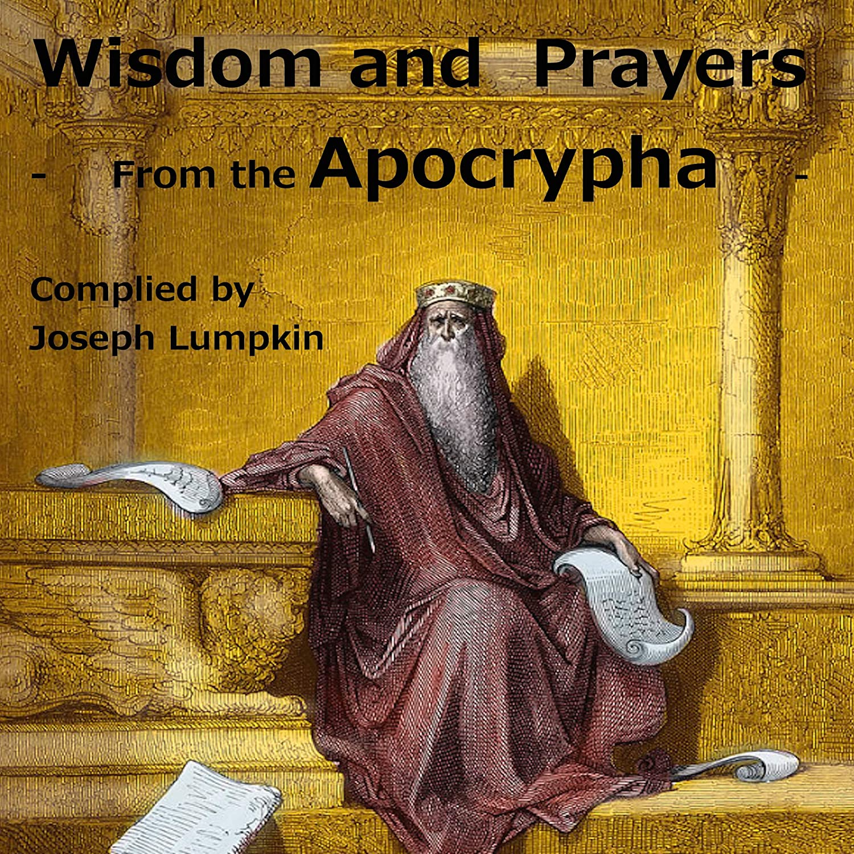

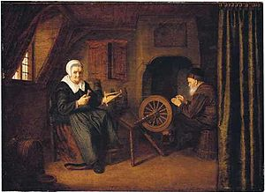
Tobit and Anna by Abraham de Pape c. 1658

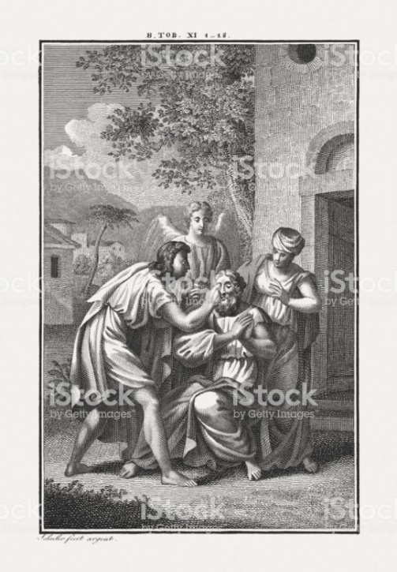
Tobit Curing a Blind Man

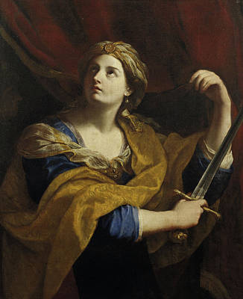
Judith with a swordD
Guido Reni
Italy, 1575-1642

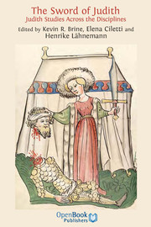
Title Page, 15th Century German Bible
Workshop of Diebold Lauber

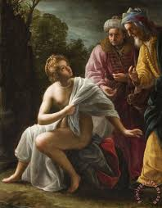
Susanna and the Elders
Jean François de Troy
France (1649-1752)

